Day5 – Task 1

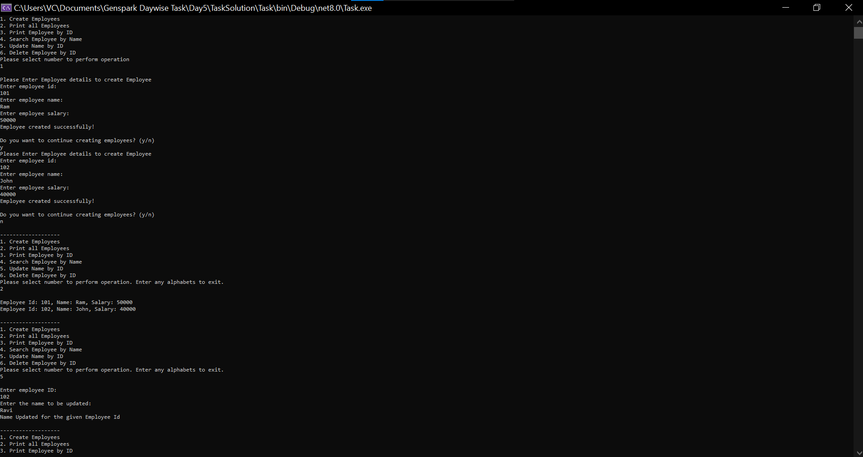-----Output-----